**Engaging Education: Enhancing Learning with GooseChase Scavenger Hunt**

Sadia Shaheed

ITEC-830: Design of Learning Environment with Emerging Technologies

Dr. Brian Beatty

April 12, 2023

**Introduction**

GooseChase is a sought-after application for team building, which operates through mobile devices and involves a scavenger hunt. The participants are required to fulfill various missions, including capturing pictures or videos, providing brief responses, and utilizing GPS location. It offers an engaging way to promote active learning through scavenger hunts. According to Schwartzman, one advantage of implementing an active learning strategy with clearly defined learning objectives at the beginning of a course or module is that it fosters a dynamic and engaged classroom environment (Jones, Smith, & Royster, 2017).

**Features**

GooseChase has become increasingly popular in educational settings due to its ability to engage students in fun and interactive learning experiences. This scavenger hunt platform can also serve pedagogical needs in K-12 education. Teachers can design educational scavenger hunts that engage students in active learning, team building, and problem-solving. It can help create an immersive and interactive learning experience for students, fostering critical thinking and collaboration skills. Figure 1 shows the steps to create a Goosechase challenge.

To get started with GooseChase, the teacher or creator first needs to create an account on the platform. Once the account is created, creators can start creating the first GooseChase game. To do this, a game title, a description, and to set a date and time for when the game will take place are needed.

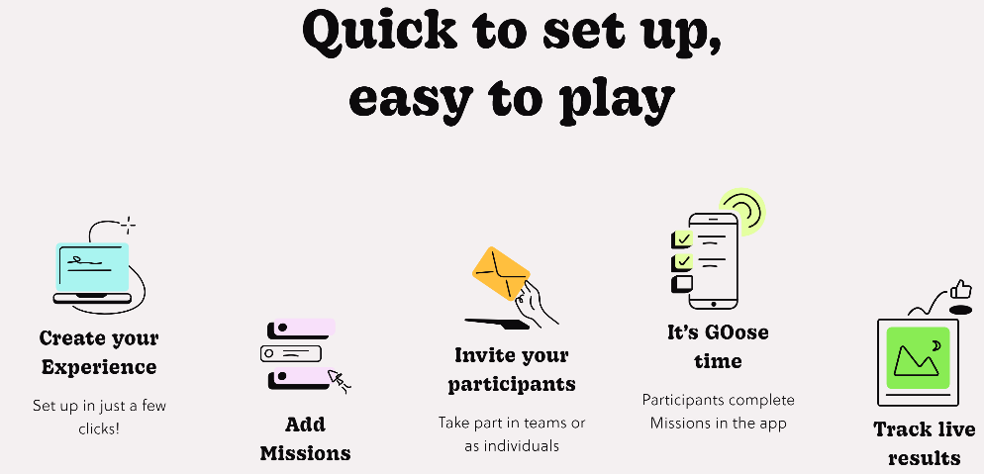

*Figure 1: steps to create a challenge in Goosechase*

Next, the creator needs to create missions for the game. Missions can be text-based, photo-based, or video-based, figure 2 shows various templates available to use. GPS coordinates can be added to missions to make them location-specific. Creator can set the points for each mission and customize the time limits for completing them.

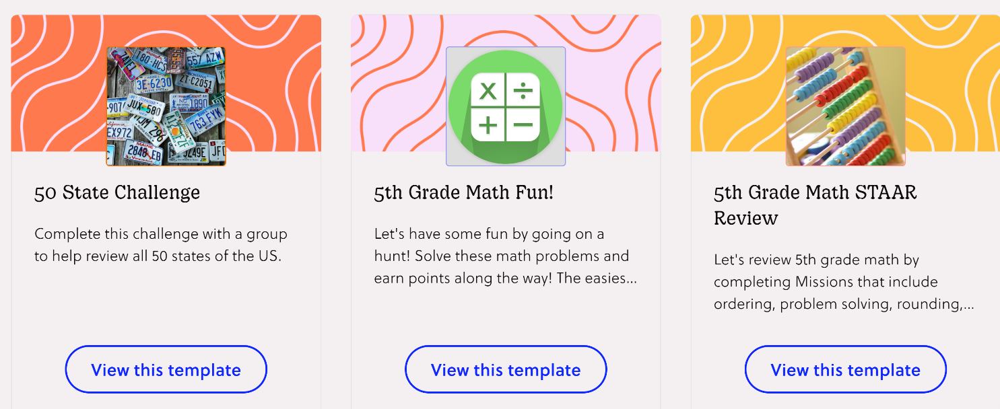

*Figure 2: Goosechase offers various templates ready to use*

Once the mission is created, an invite can be sent to participants to join the game. Participants can be added manually or by sharing a unique code. Teachers can also create teams within the game and assign missions to specific teams. Figure 3 shows a sample challenge for reviewing school-grade students’ chemistry knowledge.

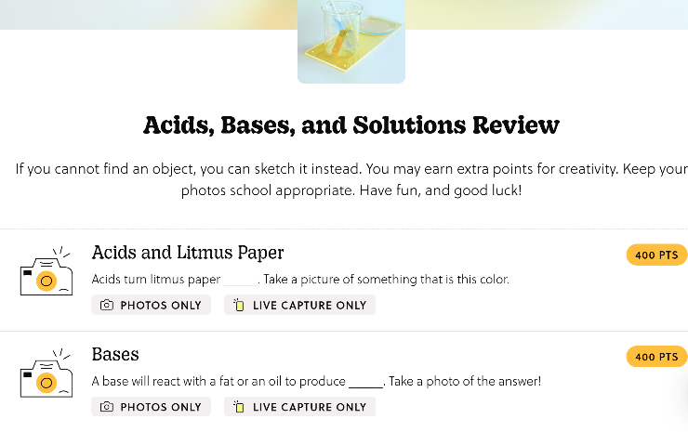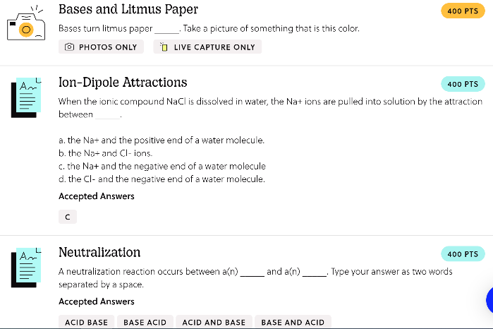

*Figure 3: Reviewing Chemistry knowledge with Goosechase challenge*

Throughout the game, participants can use the GooseChase app on their mobile devices to complete missions. The app allows them to take photos, record videos, and submit responses to missions. Participants can also track their progress and see the leaderboard to see how they are doing compared to other teams.

To facilitate the scavenger hunt during the game, monitoring students' progress and providing feedback and support is needed. After the game, teachers or instructors can review the results and use the data to evaluate student learning and adjust future activities.

*Accessibility:* GooseChase is accessible from both iOS and Android phones. A computer is needed to create the game but participants or groups can join with phones only.

**Impact on learning**

When utilized in the appropriate context, GooseChase can offer significant educational value. Its pedagogical benefits are as follows:

*Active learning*: GooseChase necessitates that students actively participate in the learning process by finishing tasks, tackling challenges, and exploring the content. This fosters a more hands-on approach to learning, which is more effective than passive learning. Students take an active role in their learning, this can help them develop a deeper understanding of the subject matter. Figure 4 shows active learning options for 27 Amendments in Goosechase.

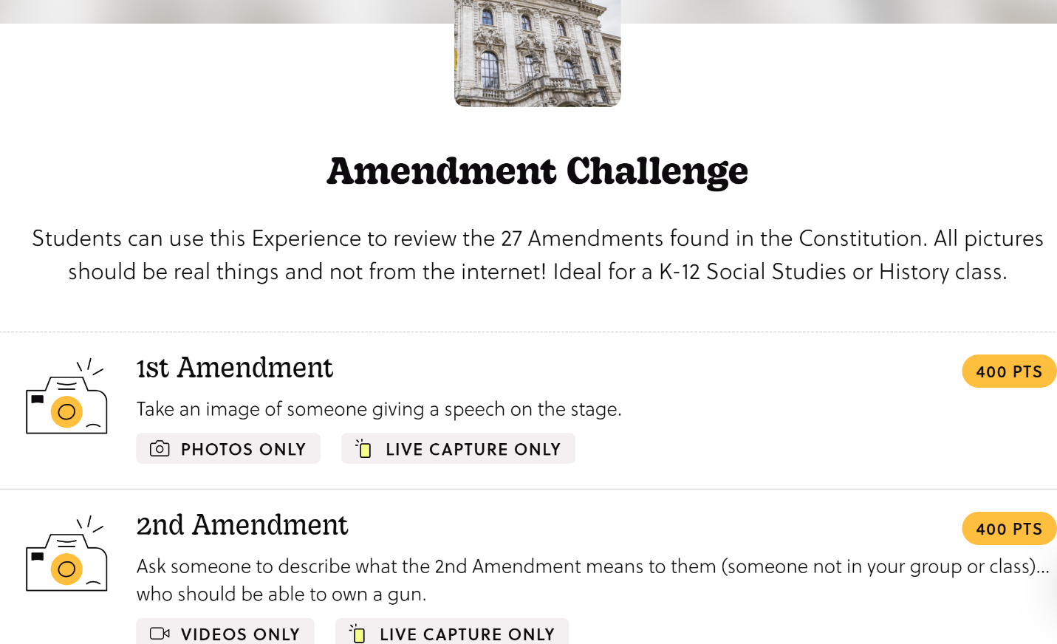

*Figure 4: Template for reviewing 27 Amendments in Goosechase*

*Collaboration*: The scavenger hunt can be played in teams, encouraging collaboration, communication, and problem-solving abilities. By working together, students can learn from one another, exchange ideas, and enhance their understanding of the subject matter. According to Roschelle, “Collaborative work between peers provides a particularly rich environment for studying learning” (Roschelle, 1995).

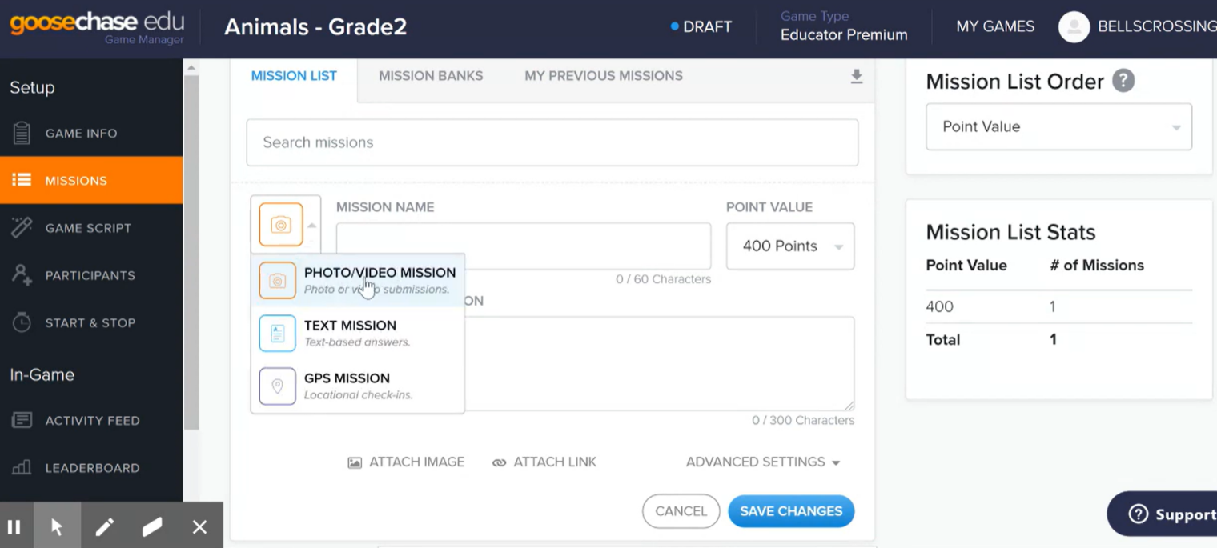Figure 5: Options to add multimedia in GooseChase

*Integration of Multimedia:* It enables educators to incorporate multimedia components, such as photos, videos, and audio clips, into their tasks and challenges. This can make learning more engaging and memorable by catering to various learning styles and preferences. Figure 5 shows various options for teachers to add multimedia and there are options for multimedia response too.

*Formative assessment*: GooseChase can serve as a form of formative assessment to gauge student comprehension of the material. Teachers can track student progress in real-time, offer feedback, and adjust the game to address any areas of weakness. Figure 6 shows how students are connecting their ideas or knowledge to real-life elements.

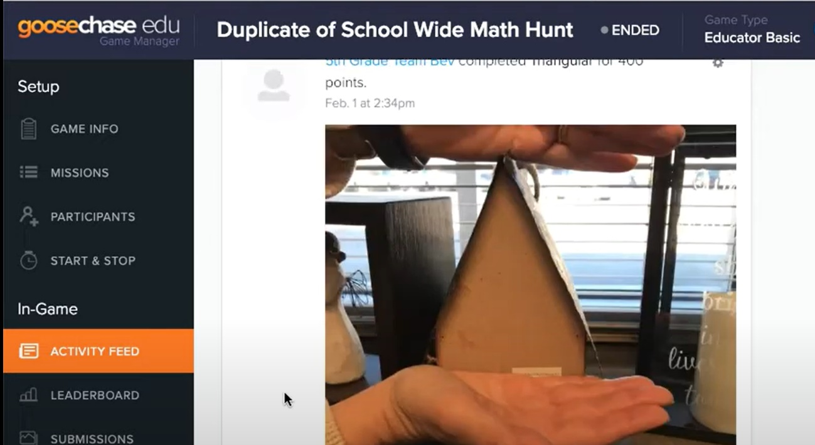

Figure 6: Activity feed showing real-time engagement

*Immediate feedback*: GooseChase provides instant feedback to students on their progress, motivating and encouraging them to keep learning. This can help establish confidence and create a sense of achievement, both of which are critical for student motivation.**Top of Form**

*Customization:* GooseChase can be customized for different or slow learners by adjusting the difficulty level of tasks and challenges. Teachers can create tasks that are tailored to the individual needs of each student, ensuring that they are challenged but not overwhelmed. Additionally, teachers can provide additional resources, such as hints or links to relevant materials, to support students who may need extra help.

*Real-world applications*: GooseChase provides interactive experiences that help students develop problem-solving and collaboration skills, apply their learning to real-world scenarios, and bridge the gap between theory and practical application. It incorporates multimedia elements and offers immediate feedback and assessments. Figure 7 shows multimedia responses on GooseChase from participants joining the challenge.

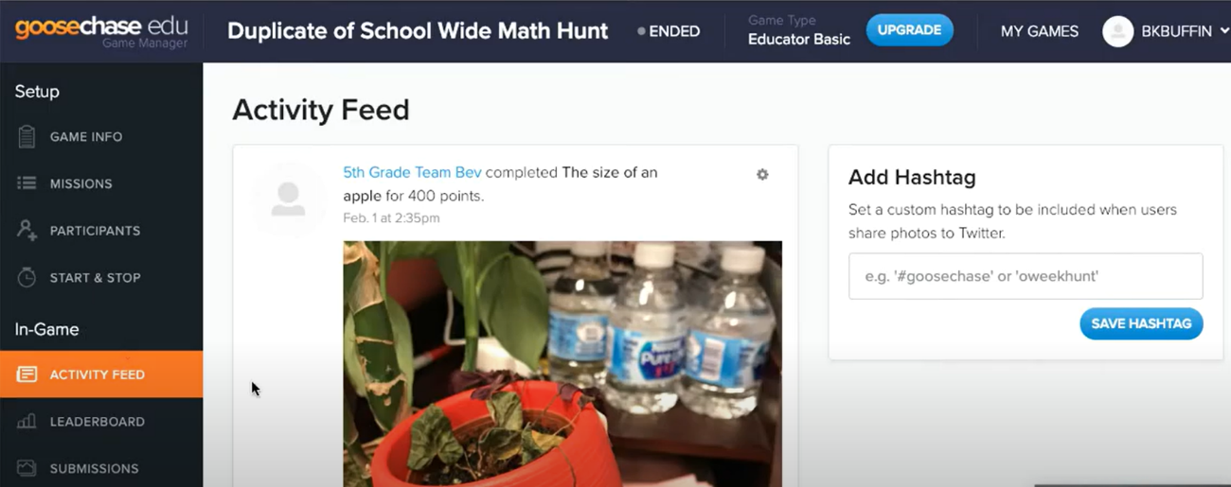

Figure 7: Students posting multimedia responses to show their skills and knowledge

*Limitations:* GooseChase offers both free and paid versions of its application. The free version provides basic features, while the paid version offers additional functionalities and customization options. It’s not clear if any other language is offered in this app depending on location except for English.

*Privacy and security:* App privacy claims that they only use users’ personal information when the law allows them to. The site claims that they don't collect data from individuals under 13, and the platform is not intended for that age and under unless the relevant institution has obtained consent and authorization for them to use it and for developers to collect their information as per COPPA and this Privacy Policy (Goosechase, 2022).

**Conclusion**

Overall, GooseChase is a versatile tool that can be used to meet a range of pedagogical needs in K-12 education. Its gamified format and interactive elements can help engage students and promote active learning. According to Villagrasa, gamification in learning goes beyond the use of badges, rewards, and points. Rather, it involves evaluating progress and fostering motivation. For students, motivation is crucial to successful learning, as they require a sense of achievement and fulfillment from overcoming challenges. By providing a means of measuring progress, students can experience the satisfaction of overcoming obstacles and feel empowered to tackle new ones (Villagrasa, 2014). When used effectively, platforms like this can enhance student engagement and motivation, leading to better learning outcomes.

# References

*Goosechase*. (2022, August 8). Retrieved from Goosechase: https://www.goosechase.com/privacy

Jones, J. A., Smith, S., & Royster, M. (2017). The Scavenger Hunt as an Active Learning Technique. *NACTA Journal*, 94-95.

Roschelle, J. &. (1995). The Construction of Shared Knowledge in Collaborative Problem Solving. *Computer Supported Collaborative Learning. 10*.

Villagrasa, S. F. (2014). Teaching Case of Gamification and Visual Technologies for Education. *Journal of Cases on Information Technology (JCIT), 16(4)*, 38-57.

Top of Form